**CS551 Midterm Exam Report**

**Name:** Sumanth Koushik Kalli

**Student ID:** 16158017

1. **Design:**
2. **Architectural Diagram:**

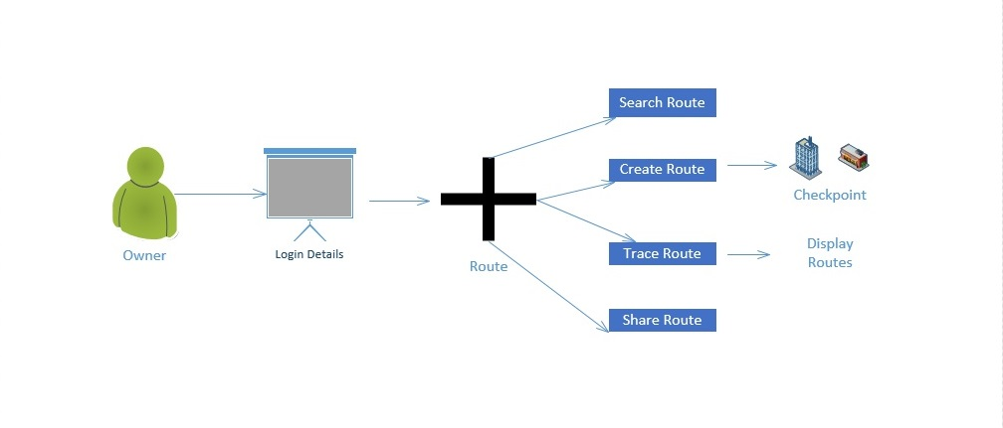

1. **Class Diagram:**

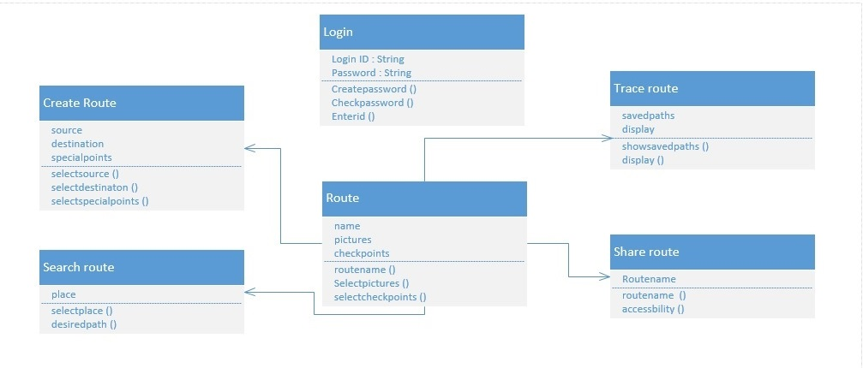

1. **Features Implemented:**
2. **Web Services:**

In this application for CS551 Midterm Exam, I created a mobile app and mobile web interface in according to the guidelines given.

The application created allows the user to create his/her personalized account and search for routes and venues. It also allows the users to login with their four square account credentials and all the routes which have been searched by the user will be saved to their four square accounts by clicking the save to four square option on the bottom of each selected venue.

After the users logs in with his/her login credentials he will asked to request the city and venue which he wanted to search and then the results will be displayed on the same page along with photos(if available on four square). The user will also get the reviews of the venue or destination selected which are written by the other users or the users who have previously visited the place.

I have also included a flavor of Recommendations to this applications by developing the Trend Results which can are used to display other related items in the location.

I have used the existing Foursquare API and Google Maps API for saving the routes and displaying them on the Google Maps for better visualization.

1. **Database:**

I have used the datasets of the four square to obtain information for the search results and it contains name of the place, its postal address, review written by other visited users etc. Also, Google Maps API is used to get the location based data and plot them on the maps.

In this application, I have used the MySQL database to store details of the users and also their saved searches and visited places.

1. **Mobile User Interface:**

The user interface for this application contains both the mobile app version and also the mobile web application. The cascaded styling sheets are developed to make the application fit into both mobile app and mobile web interface.

The Four square API and Google Maps API already have their mobile App versions. So, it is quite easy in developing a good view for the mobile app version.

1. **Screenshots:**

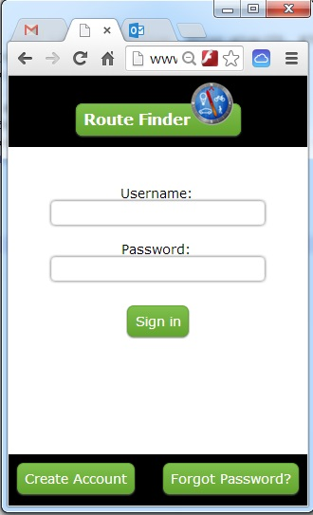

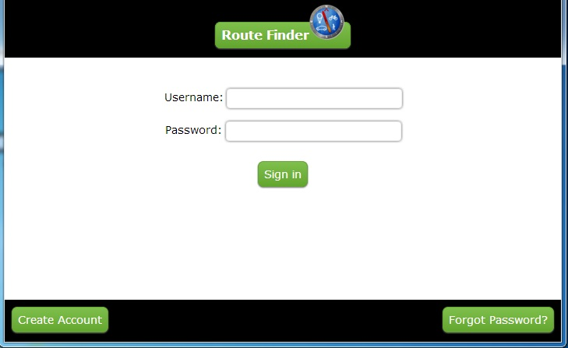

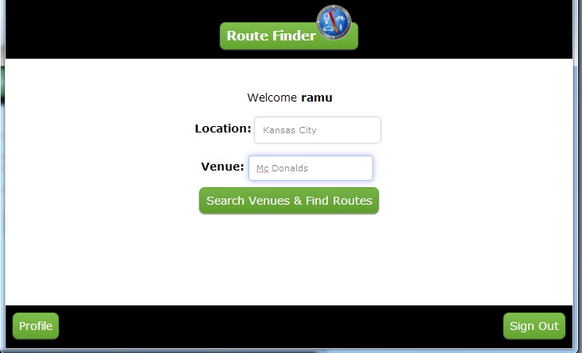

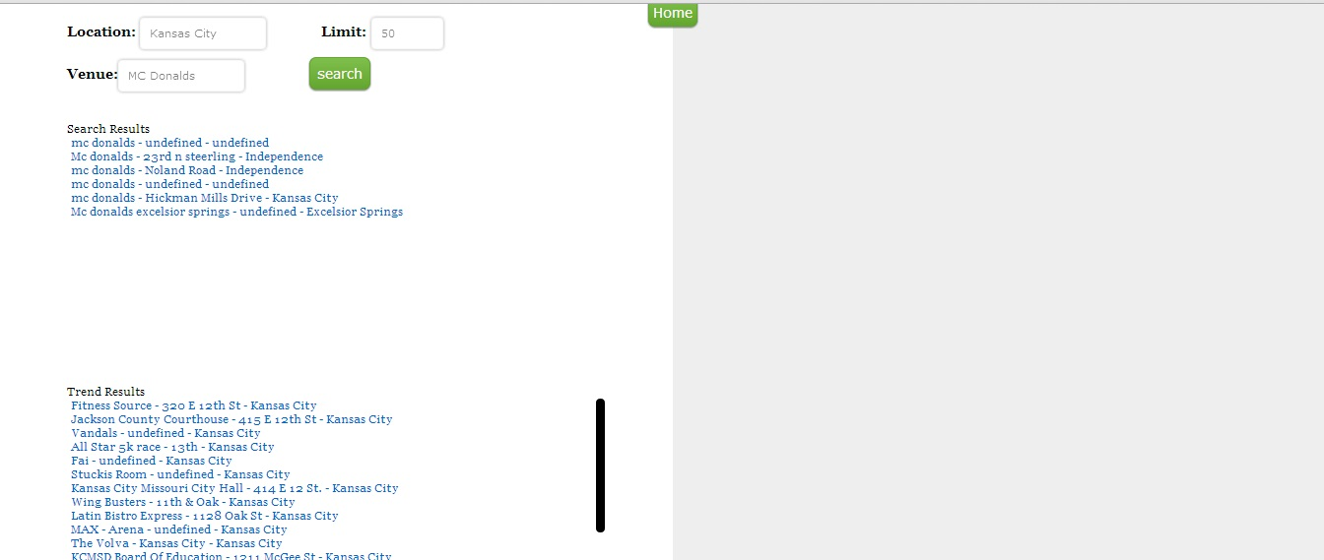

**I have also included the Trend Results option where in we also get other recommendations based on our search and it is indicated in the below screenshot.**

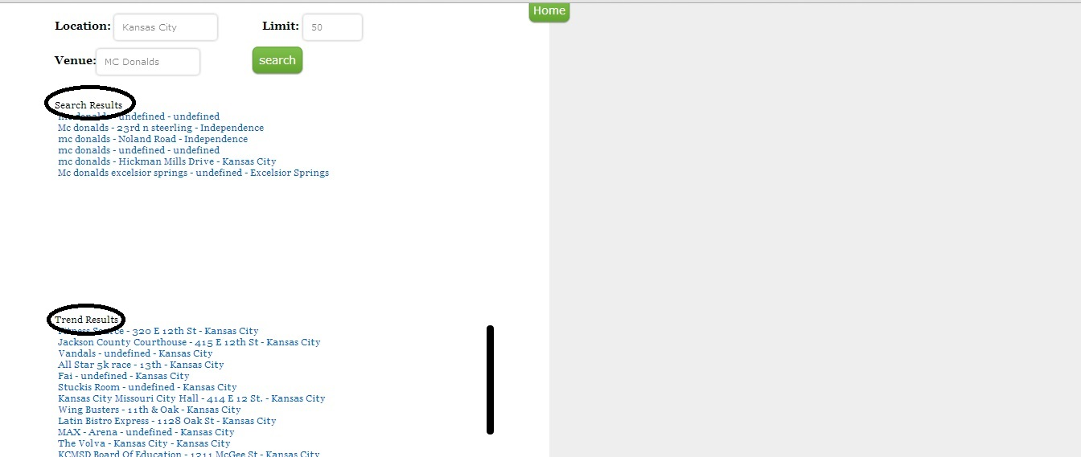

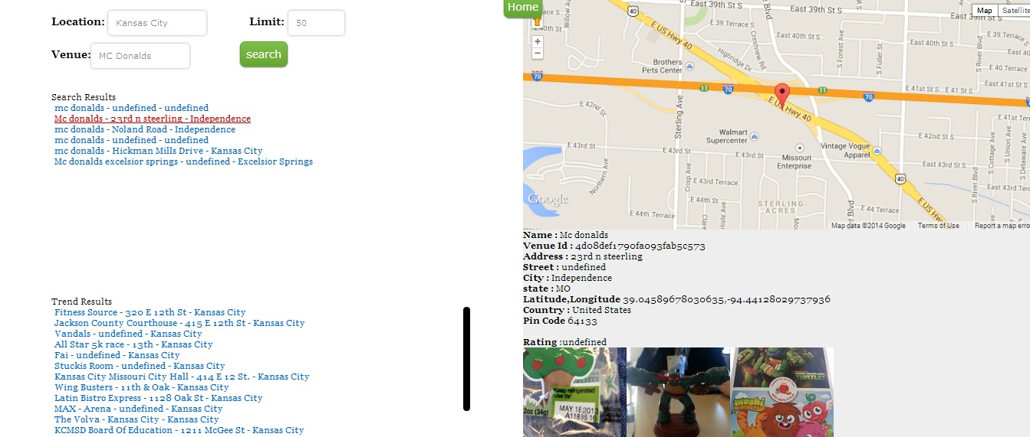

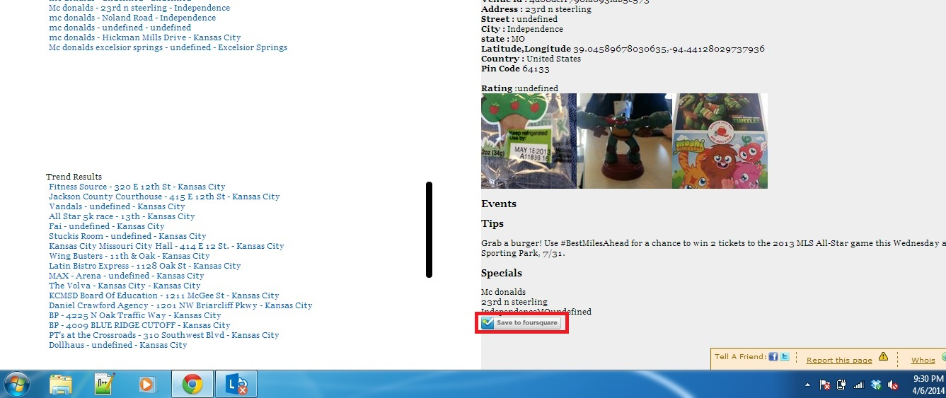

1. **Web Service and Website URL’s:**

I have used the Google Maps API and Foursquare API in this application and the URL’s for both are given below:

**Google Maps API:**  https://developers.google.com/maps/

**FourSquare API:** <https://developer.foursquare.com/start/search>

<https://developer.foursquare.com/start/interact>

https://developer.foursquare.com/start/realtime

1. **Github URL:** https://github.com/sumanth2109/AdvancedSoftwareEngineering/tree/master/Mid%20Term%20Exam
2. **Limitations:**

The limitation of this application lies in the searching options for different venues.

Also, time has been a major limitation in developing this application.

1. **References:**

**FourSquare.com:** https://developer.foursquare.com/

**Google Developer Site:** <https://developers.google.com/>

**Stack Overflow:** http://stackoverflow.com/